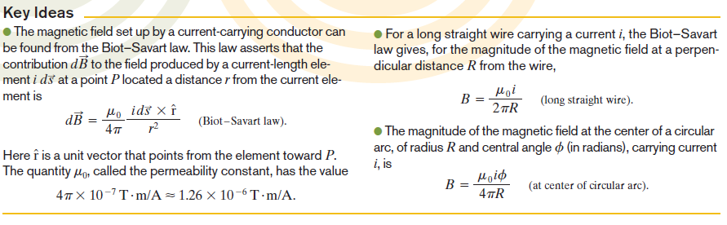

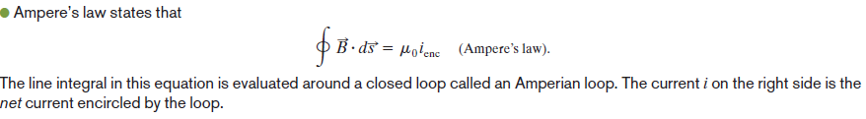

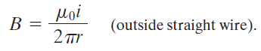

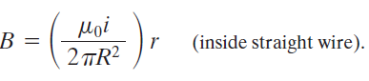

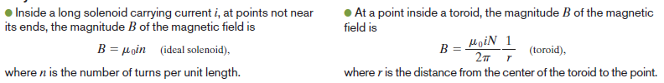

**Problems Based on Hall Effect, Biot Savart Law and applications and Ampere’s Law and its application**

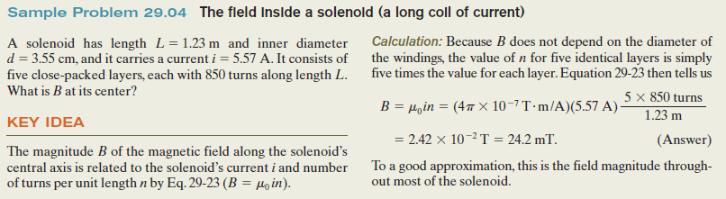

Q1. A solenoid that is 95.0 cm long has a radius of 2.00 cm and a winding of 1200 turns; it carries a current of 3.60 A. Calculate the magnitude of the magnetic field inside the solenoid.

(Ans:0.00571T)

Q2.A long solenoid has 100 turns/cm and carries current *i*. An electron moves within the solenoid in a circle of radius 2.30 cm

perpendicular to the solenoid axis. The speed of the electron is 0.0460*c* (*c=*speed of light). Find the current *i* in the solenoid. (Ans: 0.272A)

Q3. Calculate the magnitude of the magnetic field at a point 100 cm from a long, thin conductor carrying a current of 1.00 A. (Ans: 2.00x10-7T)

Q4. Determine the magnetic field at a point *P* located a distance *x* from the corner of an infinitely long wire bent at a right angle, as shown in Figure 1. The wire carries a steady current i*.*

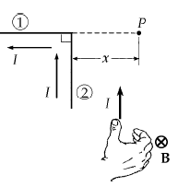**Ans:**

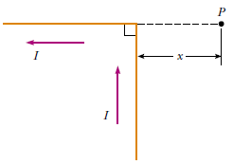

Fig 1

Q5. The segment of wire in Figure 2 carries a current of *i=* 5.00 A, where the radius of the circular arc is *R* = 3.00 cm. Determine the magnitude and direction of the magnetic field at the origin.(Ans: 26.2

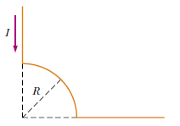

Fig 2

**Hall Effect Derrivation and Problem:**

